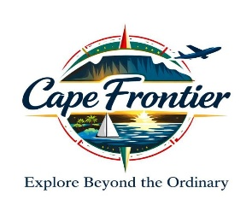

SAFETY & COMPLIANCE DOCUMENT
Heritage, Faith & Cape Flats Community Tour
Cape Frontier Travel & Tours – Cape Town, South Africa
1. Purpose of This Document
This Safety & Compliance Document outlines the operational, ethical, and risk‑management standards applied during township visits, cultural immersion activities, and community‑outreach food distribution. It ensures that all guests, staff, and community members are protected, respected, and engaged in a dignified manner.
2. Legal & Regulatory Compliance
Cape Frontier Travel & Tours operates under full compliance with South African tourism and transport regulations:
- Tourism Act 3 of 2014
- City of Cape Town Community Tourism Guidelines
- Passenger Transport Regulations
- Public Liability & Passenger Liability Insurance
- Roadworthy & Operating Licence Requirements
3. Risk Assessment & Mitigation
Township visits require structured risk planning. We implement:
- Pre‑visit area assessments
- Guided movement only
- Emergency readiness protocols
- Continuous situational awareness
4. Community Partnership Compliance
All outreach activities are conducted with verified community organisations to ensure safe, dignified, and community‑approved engagement.
5. Guest Safety Protocols
- Guests receive a pre‑tour briefing and follow:
- Movement protocols
- Respectful behavioural expectations
- Guide‑led navigation at all times
6. Food Distribution Safety
Food distribution is conducted in a controlled, hygienic, and dignified manner with:

- Proper food handling
- Crowd management
- Community supervision
7. Staff Training & Competency
All staff are trained in:
- Cultural sensitivity
- Conflict de‑escalation
- First‑aid basics
- Ethical tourism practices

8. Insurance & Liability
We maintain:
- Public Liability Insurance
- Passenger Liability Insurance
- Vehicle Insurance
- Community‑engagement coverage
9. Ethical Tourism Principles
We commit to:
- Respectful storytelling
- Non‑exploitation
- Ensuring community benefit from every booking
10. Incident Reporting
Any incident is documented and reported through:
- Internal logs
- Community partner communication
- Insurance channels

Footer
Cape Frontier Travel & Tours — Safety & Compliance Framework

